In the Traditional way of creating the objects we use the functions as the constructor function, that will construct the object

We put all the properties inside that constructor function

We already know that in javascript every object has it’s prototype object

We put all the methods inside the prototype object of the constructor function

Actually, methods will be defined in the prototype object of the objects that would be created from that constructor function

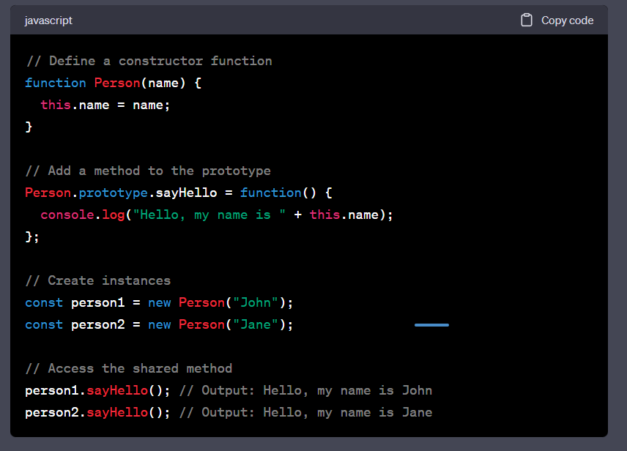

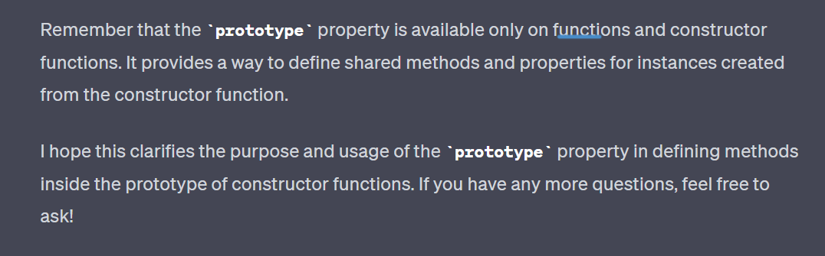

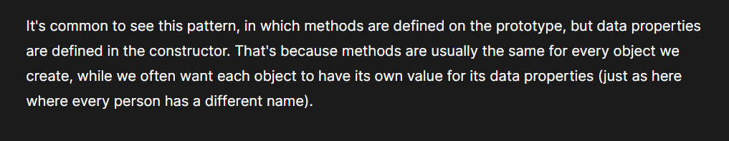

How inheritance is performed

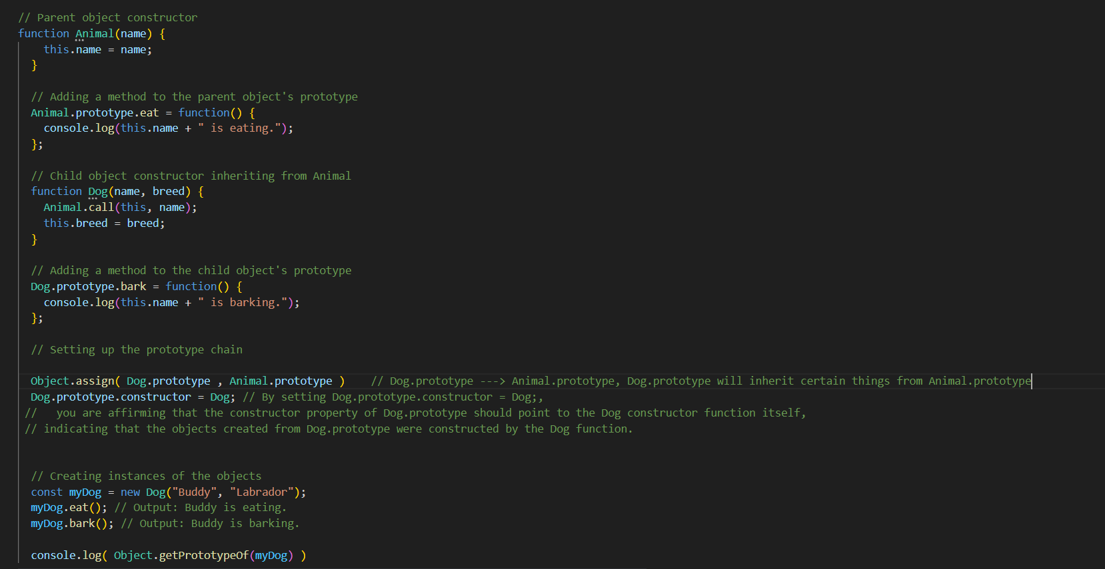

To set up the prototype chain we may any of these two methods

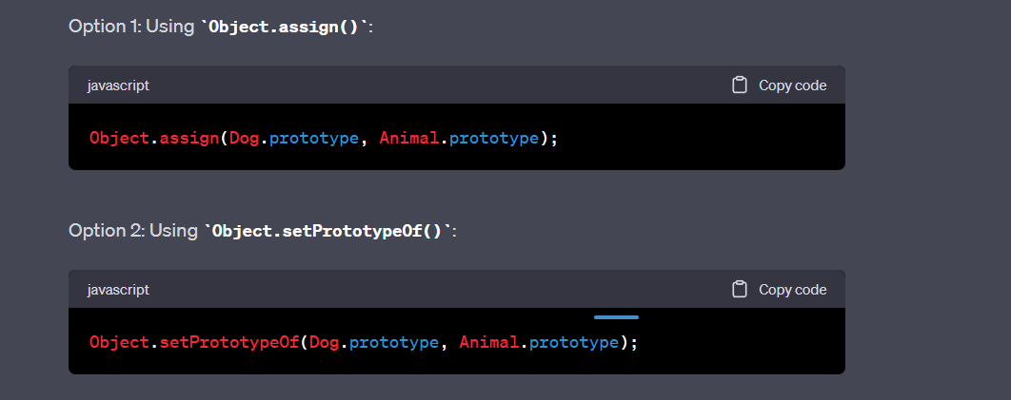

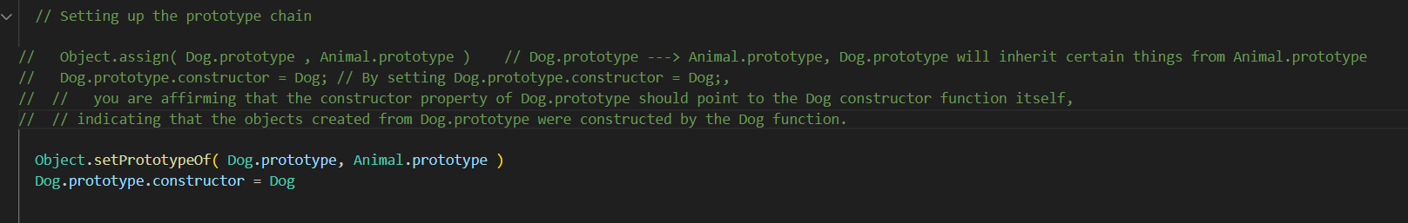

We may use any of these methods